(MAKE THE COMPLETE DOCUMENT AS PER THE FORMAT)

ACASA
SPROJ Report



Ammad Akram 25100277
Shabbir 25100132
Saad Liaquat 25100259
Rida Amir 25100279

Advisor:
School of Science and Engineering
Lahore University of Management Sciences
Submission Date
Acknowledgement and Dedication

Certificate
I certify that the senior project titled “ACASA” was completed under my supervision by the following students:

___________________________________________________________________
___________________________________________________________________
___________________________________________________________________

and the project deliverables meet the requirements of the program.

------------------------------------- Date:
Advisor (Signature)

------------------------------------- Date:
Co-advisor (if any)

Table of Contents (CHECK FORMAT)

Acknowledgement and Dedication

Certificate

Table of Contents

List of Figures

Introduction

System Requirements

System Actors

Functional Requirements

Non-functional Requirements

System Architecture

Architecture Diagram

Architecture Description

Justification of the Architecture

Tools and Technologies

Requirements Specifications

Use Cases

Class Diagram

Sequence Diagrams

Software Development Methodology and Plan

Software Process Selection

Gantt Chart

Database Design and Web Services

Database Design

API Specification

System User Interface

Project Security

Risk Management

Testing and Evaluation

Deployment Guidelines

Conclusion

Summary

Challenges

Future Work

Review Checklist

References

List of Figures

Figure 1. High-level System Architecture Diagram

Figure 2. Entity–Relationship (E/R) Diagram

Figure 3. Class Diagram

Figure 4. Sequence Diagram – User Authentication (UC-01)

Figure 5. Sequence Diagram – Document Upload (UC-03)

Figure 6. Sequence Diagram – Compliance Report Generation (UC-04)

Figure 7. Gantt Chart of Project Schedule

Introduction

Introduction
ACASA (Automated Compliance Auditing Software using AI) aims to automate the auditing of compliance standards such as HIPAA, ISO 27001, PCI-DSS, and GDPR. It utilizes open-source libraries and AI-driven decision-making to address current market gaps, particularly by offering a cost-effective, fully automated solution.
Domain: The project falls under the domain of Compliance Automation / Information Technology.
Target Users:
- Compliance Officers
- IT Security Teams
- Executives
- Auditors
Product:
The product is a software system designed to automate compliance auditing. It involves a combination of:
- Web-based interface for users to interact with the system.
- Backend services to process data and execute audits.
- AI-driven modules for automated analysis of compliance.
- Scripts for automating security checks.

Objective and Scope
The main objective of ACASA is to automate the auditing of compliance standards to reduce manual effort, improve accuracy, and increase efficiency. The system aims to provide a cost-effective solution that streamlines compliance processes for organizations.
The scope of the project includes:
- Automating compliance checks for standards like HIPAA, ISO 27001, PCI-DSS, and GDPR.
- Developing AI modules to analyze compliance-related documents and configurations.
- Creating a user-friendly dashboard for compliance officers, IT security teams, executives, and auditors.
- Implementing features for document uploads, audit log reviews, and report generation.

Development Methodology
The development of ACASA follows the Agile-Scrum process. This methodology was chosen to allow for iterative development, flexibility in adapting to changing requirements, continuous stakeholder feedback, and better risk management. The project is divided into sprints, with each sprint focusing on delivering a working increment of the software.

Contributions
ACASA contributes to the field by:
- Automating compliance auditing, which significantly reduces the time and resources required for audits.
- Providing an AI-driven solution that enhances the accuracy and comprehensiveness of audits.
- Offering a cost-effective solution that makes compliance automation accessible to a wider range of organizations.
- Improving the audit process by providing real-time monitoring, detailed reporting, and proactive compliance management.

System Requirements
Brief introduction of this chapter in a paragraph highlighting the content

System Actors
List down the actor names and give a 2-3 lines description of the role of each actor
Actor Name | Description
Compliance Office | Compliance Officer: Responsible for ensuring that the organization adheres to relevant compliance standards.
IT Security Teams | Manage endpoint security and ensure systems remain compliant with industry regulations.
Executives | Require high-level reports on the organization’s compliance status for decision-making purposes.
Auditors | Conduct compliance audits either internally or externally, ensuring adherence to set standards.

Functional Requirements
[FR-1] As a compliance officer, I want to perform automated compliance audits to reduce manual effort.
[FR-2] As an IT security team member, I want to monitor endpoint security in real-time to ensure compliance with required standards (ISO 27001 Control 8.1 - User endpoint devices).
[FR-3] As an IT security team member, I want to ensure that access is restricted to privileged systems and actions (ISO 27001 Control 8.2 - Privileged access rights).
[FR-4] As an IT security team member, I want to ensure access to sensitive information is restricted based on user roles (ISO 27001 Control 8.3 - Information access restriction).
[FR-5] As an IT security team member, I want to monitor access to source code, so only authorized personnel can view and modify it (ISO 27001 Control 8.4 - Access to source code).
[FR-6] As an IT security team member, I want to monitor system capacity to ensure resources are sufficient and prevent system overload (ISO 27001 Control 8.6 - Capacity management).
[FR-7] As an IT security team member, I want to observe that the implemented network security protocols work properly to protect against unauthorized access (ISO 27001 Control 8.20 - Network security).
[FR-8] As an IT security team member, I want to ensure proper configurations are applied to network services to ensure secure access and communication (ISO 27001 Control 8.21 - Security of network services).
[FR-9] As an IT security team member, I want to monitor the segregation of networks to limit exposure in case of a breach (ISO 27001 Control 8.22 - Segregation of networks).
[FR-10] As an IT security team member, I want to observe applied web filtering controls to ensure that access to malicious or harmful websites is blocked (ISO 27001 Control 8.23 - Web filtering).
[FR-11] As an executive, I want to ensure that high-level compliance reports to get an overview of the organization’s status.
[FR-12] As an auditor, I want to review compliance audit logs to verify the organization’s adherence to security regulations.
[FR-13] As a compliance officer, I want to ensure that information security policies are in place, communicated to relevant personnel, and regularly reviewed (ISO 27001 Control 5.1 - Policies for information security).
[FR-14] As a compliance officer, I want to make certain that segregation of duties within the organization is applied to prevent conflicts of interest (ISO 27001 Control 5.3 - Segregation of duties).
[FR-15] As a compliance officer, I want to certify that labels on information are based on its sensitivity to ensure proper handling and protection (ISO 27001 Control 5.12 - Classification of information).
[FR-16] As a compliance officer, I want to certify that labels on information are based on its classification to aid in its protection (ISO 27001 Control 5.13 - Labeling of information).
[FR-17] As a compliance officer, I want to ensure that access control measures are enforced to verify that only authorized individuals can access sensitive information (ISO 27001 Control 5.15 - Access control).
[FR-18] As a compliance officer, I want to review access rights to ensure they are granted only as necessary (ISO 27001 Control 5.18 - Access rights).
[FR-19] As a compliance officer, I want to ensure the secure use of cloud services by implementing proper information security measures (ISO 27001 Control 5.23 - Information security for use of cloud services).
[FR-20] As an HR team member, I want to ensure employees sign confidentiality or non-disclosure agreements to protect sensitive information (ISO 27001 Control 6.6 - Confidentiality or non-disclosure agreements).
- [FR-21] As an HR team member, I want to ensure that employees’ terms and conditions of employment include provisions related to information security responsibilities (ISO 27001 Control 6.2 - Terms and conditions of employment).

Non-functional Requirements
[NF-1] The system should maintain memory usage below 2 GB during typical operations and should not exceed 3 GB during peak loads, ensuring efficient performance without crashing.
[NF-2] The system should restore normal operations within 5 minutes in the event of a failure.
[NF-3] The system must load the web dashboard and other critical functionalities like audit logs within 7 seconds to provide a seamless user experience.
[NF-4] The software should be capable of handling up to 10-15 concurrent users without a degradation in performance.
[NF-5] The system should maintain a 99.9% uptime excluding planned maintenance windows, ensuring high availability for users.
[NF-6] The system should be designed in a way that allows future extension with minimal impact on the core functionalities.

System Architecture
Brief introduction of this chapter in a paragraph highlighting the content

Architecture Diagram
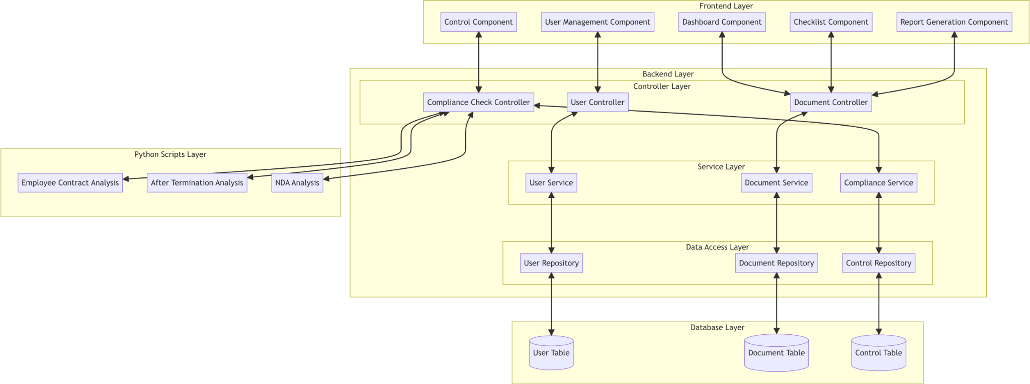

Architecture Description

Frontend Layer
- The Frontend Layer is responsible for user interaction and presenting the application interface. It is implemented using React.js and consists of modular components:
- Login Component: Manages user login functionality.
- Register Component: Handles user registration.
- Dashboard Component: Displays the compliance checklist and system status overview.
- Checklist Component: Lists all compliance controls and allows users to check or upload necessary files.
- Control Component: Handles specific compliance control operations, including automation.
- Generate Compliance Report Component: Displays a compliance report with completion percentages.
- Firewall Analysis Component: Fetches and displays whitelist and blocked site rules from the backend.
- Firewall Status Component: Retrieves and displays the current firewall status.
- Antivirus Check Component: Fetches and displays information about installed antivirus software.
- Communication with the backend is achieved through RESTful APIs.

Backend Layer
- The backend is implemented using Node.js and Express.js. It follows a layered architecture for modularity and maintainability. This layer consists of:
- Controller Layer:
- User Controller: Manages user-related operations like registration and login.
- Document Controller: Handles file upload operations and document metadata storage.
- Compliance Controller: Orchestrates compliance verification workflows.
- Firewall Controller: Handles firewall configuration and status analysis.
- Antivirus Controller: Manages antivirus checks.
- Service Layer:
- User Service: Implements the business logic for user management.
- Document Service: Processes document-related logic and interacts with repositories.
- Compliance Service: Coordinates compliance checks, triggering Python scripts when necessary.
- Firewall Service: Handles the logic for analyzing firewall rules and status.
- Antivirus Service: Manages antivirus verification logic.
- Data Access Layer:
- User Repository: Interfaces with the User table for CRUD operations.
- Document Repository: Handles operations on the Document table.
- Control Repository: Provides access to compliance control configurations.

Database Layer
- This layer uses MongoDB to persist application data. It contains:
- User Table: Stores user credentials and metadata.
- Document Table: Keeps records of uploaded documents, including file paths and associated control IDs.
- Control Table: Maintains a list of compliance controls with their respective IDs and descriptions.

Scripts Layer
- Python scripts are used for detailed analysis and specific compliance checks:
- NDA Analysis Script: Validates confidentiality agreements within uploaded documents.
- Employee Contract Analysis Script: Analyzes employee contracts for compliance-related clauses.
- After Termination Script: Checks for post-employment responsibilities in contracts.
- Firewall Rules Analysis Script: Retrieves and categorizes firewall rules into whitelist and blocked site lists.
- Firewall Status Script: Checks if the system firewall is enabled and its configuration.
- Antivirus Check Script: Identifies installed antivirus software and verifies security applications.

Justification of the Architecture
List down pros and cons of the architecture you have defined. These pros and cons must be discussed in the context of your system. Moreover, give a justification of why this architecture is appropriate for your system. Make sure that you also discuss how this architecture helps in implementation of your system’s non-functional requirements.

Pros:
- Modularity & Maintainability: Clear separation of concerns (UI, business logic, data storage, analytics).
- Scalability: Stateless backend services and a managed MongoDB database can scale horizontally.
- Flexibility: Python scripts allow easy integration of new AI-based compliance checks.
- Performance & Availability: Using RESTful APIs and asynchronous script execution keeps the UI responsive.
Cons:
- Operational Complexity: Managing multiple components (Node.js, Python, MongoDB) increases DevOps overhead.
- Latency Risk: Invoking external AI services or heavy analyses may introduce delays if not properly queued.
NFR Alignment:
- Performance: Caching at the API layer and asynchronous job queues ensure audit requests complete within defined SLAs (e.g., results within 30 seconds).
- Reliability: Decoupled services mean failures in one module (e.g., Dockerized Python script) can be isolated and retried.
- Extensibility: New compliance standards can be added by deploying additional Python scripts without impacting the core API.

Tools and Technologies
Next.js + MongoDB

Requirements Specifications

Use Cases
USE CASE DIAGRAM?

3.a.1 User Authentication
Identifier |  | UC-01
Purpose |  | Secure system access through verified user credentials.
Pre-conditions |  | User is at the login interface.
Post-conditions |  | User is authenticated and logged in.
Step # | Typical Course of Action
 | User logs in
2. | System authenticates.
3. | System grants access based on credentials.
Step # | Alternate Courses of Action
 | At Step 1 and Step 3 provide password reset or retrieval options if login fails.
Step # | Exception Paths
 | In Step 2, If system cannot access the user database, display an error and log the incident.
3.a.2 User Registration / Sign Up
Identifier |  | UC-02
Purpose |  | Enable new users to create accounts to access system features.
Pre-conditions |  | New user has valid email and agrees to terms.
Post-conditions |  | User account is created and able to access the system.
Step # | Typical Course of Action
 | User provides details;
2. | System registers and confirms via email.
Step # | Alternate Courses of Action
1. | If email is already in use, suggest login instead.
Step # | Exception Paths
1. | If registration fails, provide an error message and log the incident.

3.a.3 Document Upload for Compliance Checking
Identifier |  | UC-03
Purpose |  | Allow users to upload documents necessary for compliance evaluation.
Pre-conditions |  | User is authenticated and on the upload interface.
Post-conditions |  | Documents are stored for analysis.
Step # | Typical Course of Action
 | User uploads files
2. | System validates and stores them securely.
Step # | Alternate Courses of Action
 | Notify user of unsupported file types or sizes and provide guidance.
Step # | Exception Paths
 | If upload fails due to server issues, log the event and alert the user to try later.

3.a.4 Checklist and Proof Storage for Manual Auditing
Identifier |  | UC-05
Purpose |  | Store checklists and proofs for manual auditing of compliance rules.
Pre-conditions |  | User has checklist and proof documents ready for upload.
Post-conditions |  | Documents are stored and indexed for easy retrieval.
Step # | Typical Course of Action
 | User uploads documents
2. | System stores and indexes for retrieval.
Step # | Alternate Courses of Action
 | Go back to Home Page if document uploading is cancelled.
Step # | Exception Paths
 | If upload or storage fails, provide error feedback and troubleshooting steps.

3.a.5 Endpoint Device Compliance Check

Identifier |  | UC-06
Purpose |  | Verify endpoint device compliance with security policies.
Pre-conditions |  | Endpoint device information is uploaded to the system.
Post-conditions |  | Compliance report is generated for endpoint devices.
Step # | Typical Course of Action
 | System assesses device configurations.
2. | Generates compliance status.
Step # | Alternate Courses of Action
 | Goes back to home page in case of a cancelled scan.
Step # | Exception Paths
 | If the system cannot process data, log the error and notify the user.

3.a.6 Privileged Access Rights Compliance Audit
Identifier |  | UC-07
Purpose |  | Ensure that privileged access rights are granted in compliance with security policies.
Pre-conditions |  | Access rights data is available for audit.
Post-conditions |  | Compliance report on privileged access rights is produced.
Step # | Typical Course of Action
 | System reviews access rights.
2. | Produces a compliance report.
Step # | Alternate Courses of Action
 | Goes back to home page if scanning is cancelled.
Step # | Exception Paths
 | If access rights data is corrupt or inaccessible, escalate the issue for technical resolution.

3.a.7 Network Security Compliance Audit
Identifier |  | UC-08
Purpose |  | Assess network settings against compliance with security standards.
Pre-conditions |  | Network configuration data is provided.
Post-conditions |  | Network security compliance report is generated.
Step # | Typical Course of Action
 | System audits network security.
2. | Documents compliance in a report.
Step # | Alternate Courses of Action
 | Advises on network configuration changes if compliance is not met.
Step # | Exception Paths
 | If network data retrieval fails, notify the user and log the incident.

3.a.10 Access Control Compliance Audit
Identifier |  | UC-10
Purpose |  | Audit the effectiveness and compliance of access control mechanisms with security policies.
Pre-conditions |  | Access control configurations are uploaded to the system.
Post-conditions |  | Detailed compliance report on access controls is available.
Step # | Typical Course of Action
 | System evaluates access controls.
2. | Provides detailed compliance feedback.
Step # | Alternate Courses of Action
 | If discrepancies are identified, suggest corrective measures.
Step # | Exception Paths
 | If system fails to retrieve data, log the incident and notify the system administrator.

Class Diagram
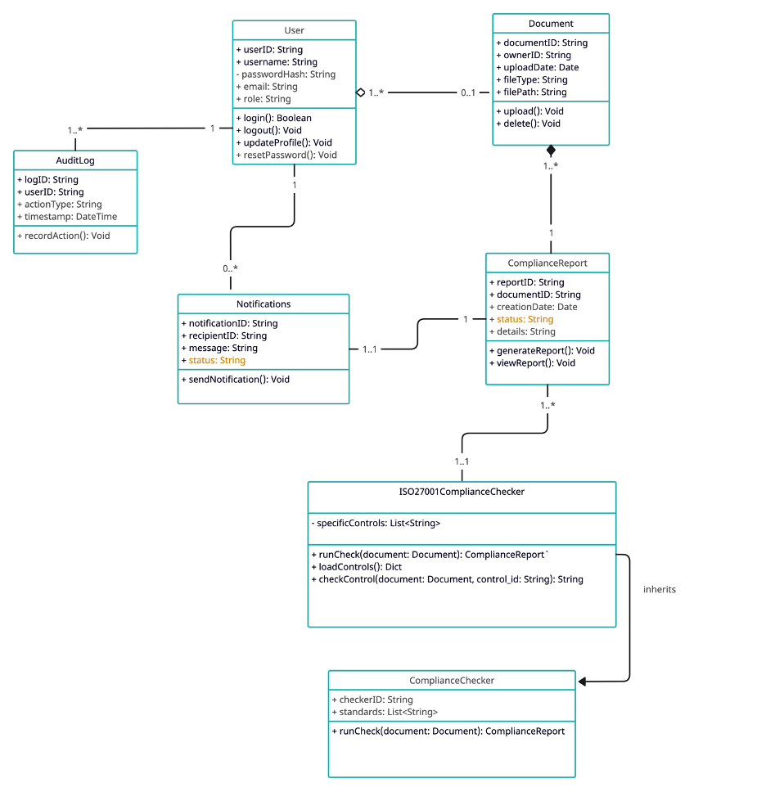
CLASS DIAGRAM DESCRIPTION?

Sequence Diagrams

UC – 01: User Authentication

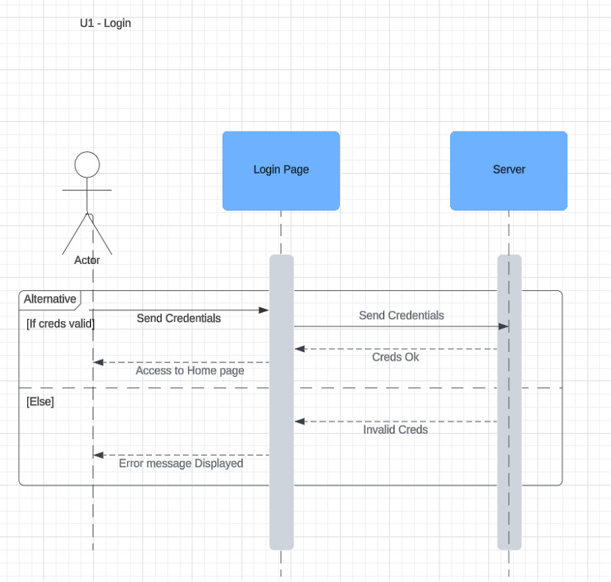

UC – 02: User Registration/Sign Up
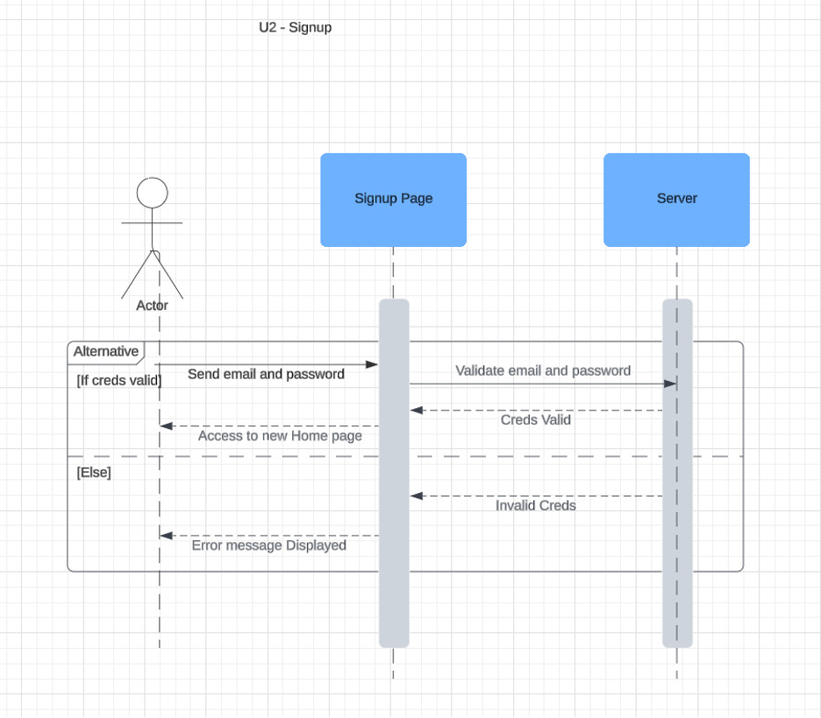

UC – 03: Document Upload for Compliance Checking
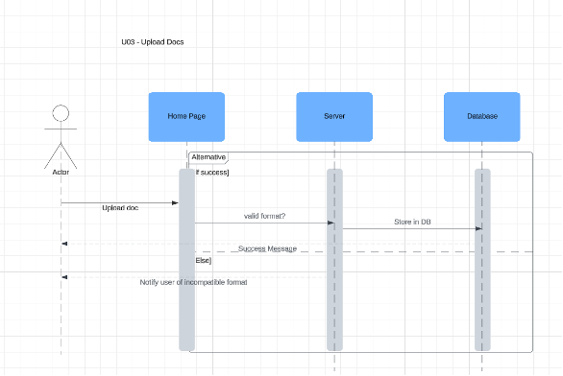

UC – 04: Compliance Report Generation
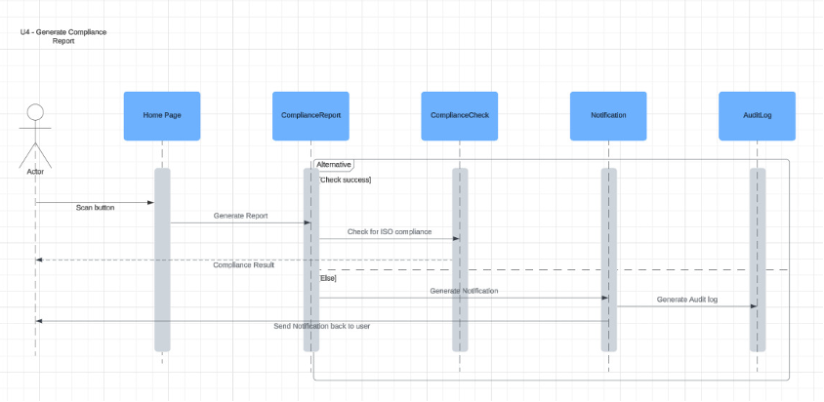

UC – 05: Checklist and Proof Storage for Manual Auditing

UC – 06: Endpoint Device Compliance Check
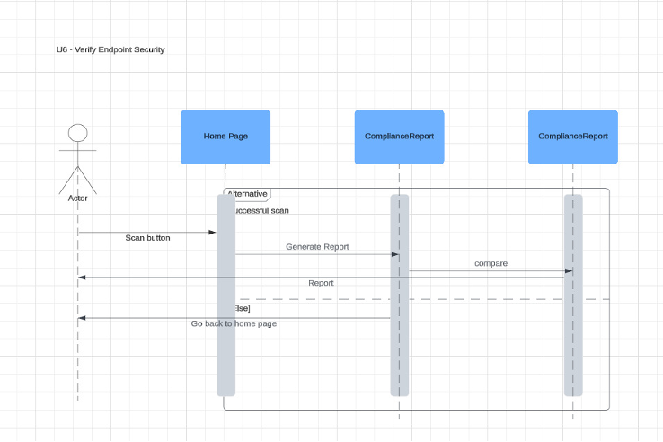

UC – 07: Privileged Access Rights Compliance Audit
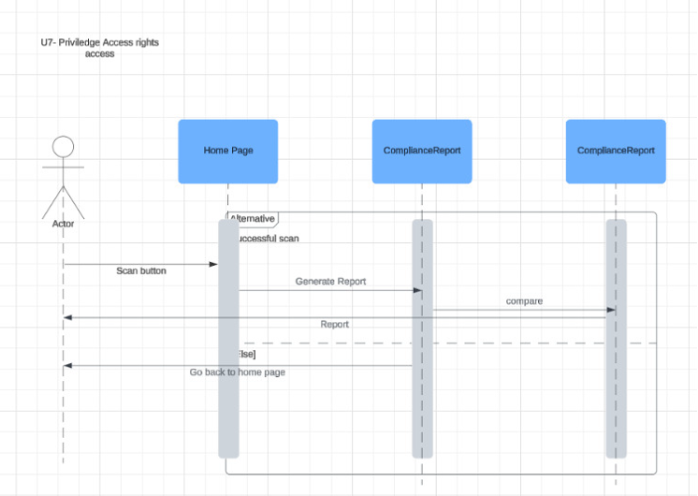

UC – 08: Network Security Compliance Audit
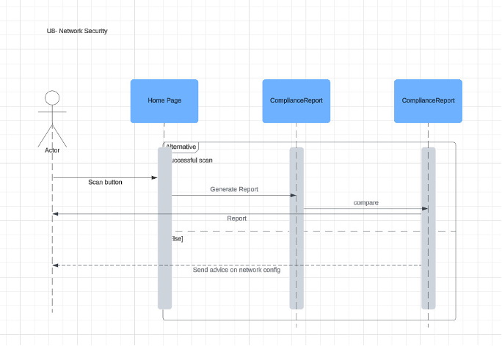

UC – 09: Cloud Services Security Compliance Audit
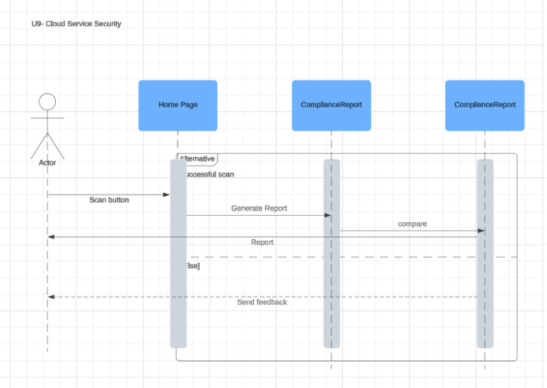

UC – 10: Access Control Compliance Audit

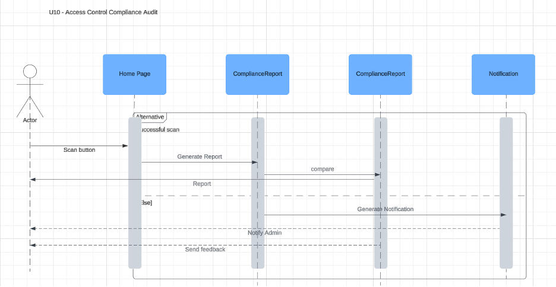

UC – 11: Information Security Policy Compliance Audit
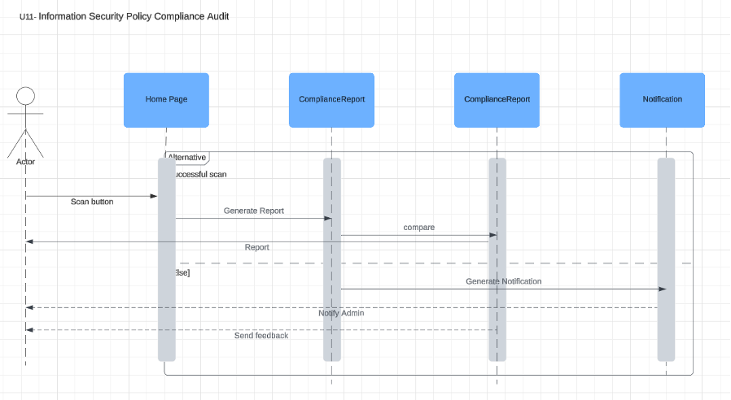

UC – 12: Web Filtering Compliance Check

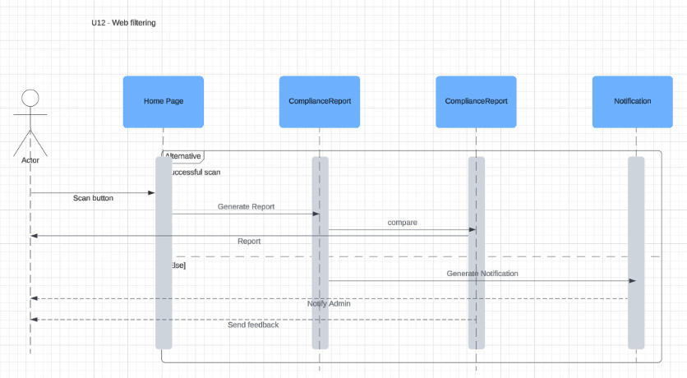

UC – 13: Employee Data Privacy Compliance Audit
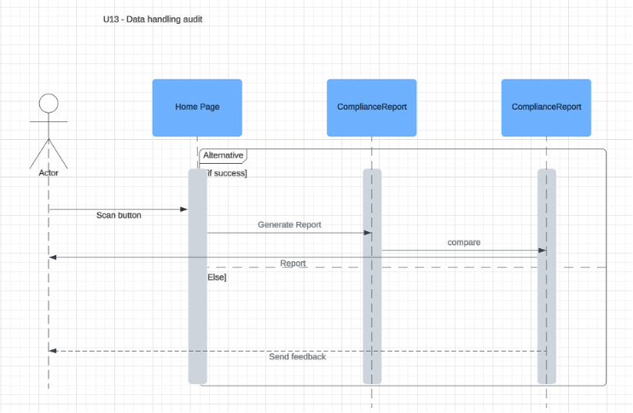

UC – 14: Contractual Agreements Compliance Check
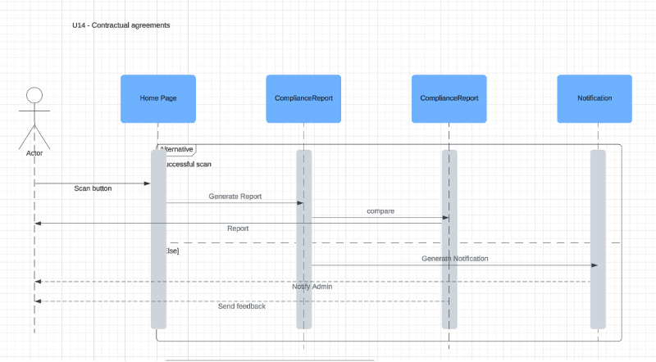

UC – 15: Source Code Access Control Audit
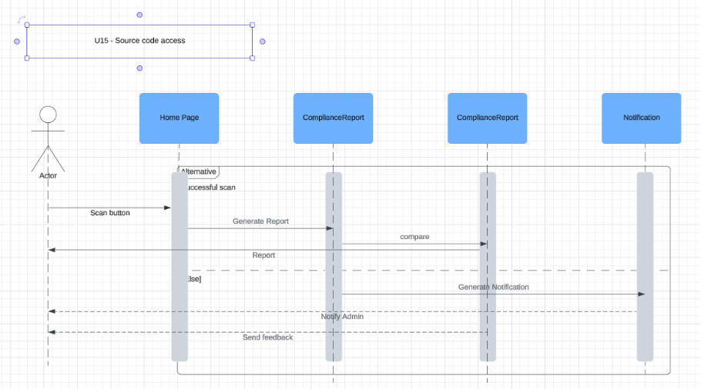

UC – 16: Information Classification Compliance Audit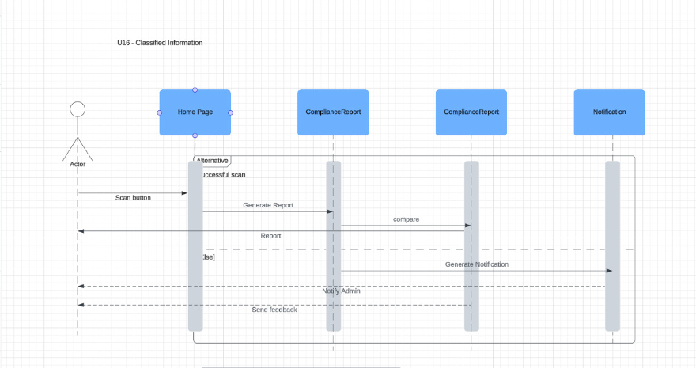

UC – 17: Cloud Service Usage Compliance Check
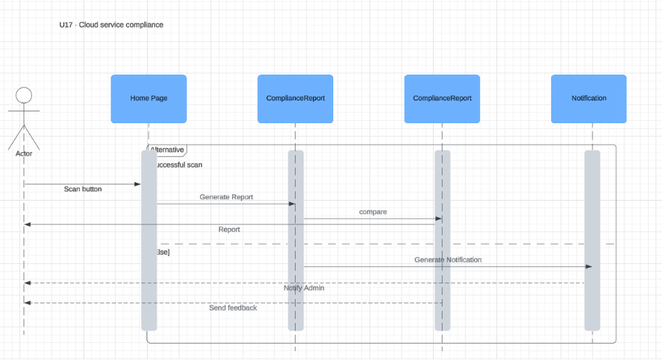

UC – 18: Terms of Employment Compliance Check
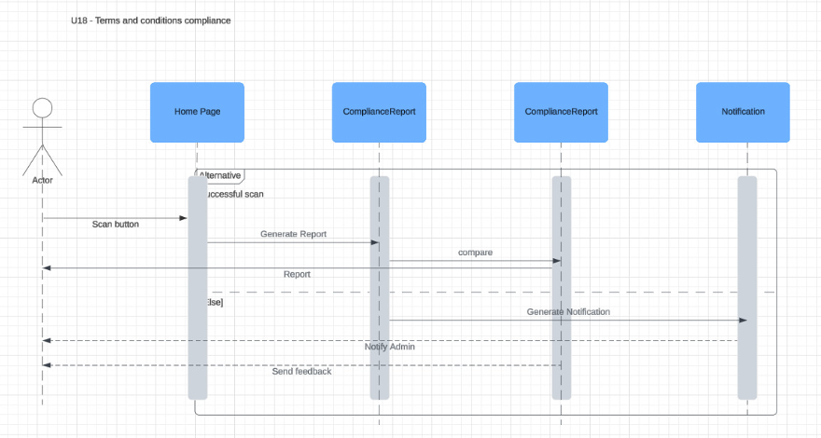

UC – 19: Confidentiality Agreement Compliance Audit
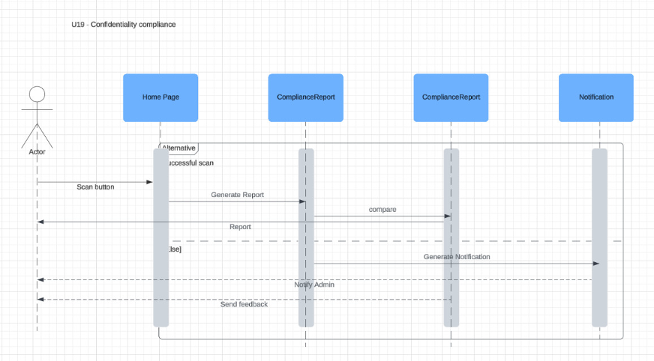

UC – 20: Data Protection Impact Assessment Audit

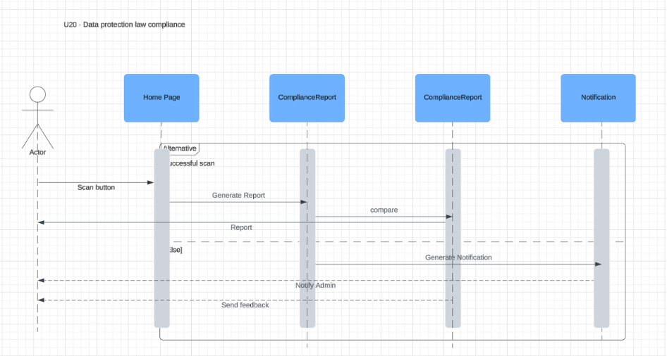

Software Development Methodology and Plan
Brief introduction of this chapter in a paragraph highlighting the content

Software Process Selection

Waterfall – Pros:
- Well-structured and predictable: Each phase (requirements, design, development, testing) is clearly defined, making early planning easier.
- Strong documentation: Helps in understanding the full scope and technical details before starting development.
- Good for fixed-scope projects: Ideal when the requirements are clear and unlikely to change.

Waterfall – Cons:
- Rigid process: Once a phase is completed, it’s hard to go back and make changes without disrupting the flow.
- Late feedback: Testing and user feedback typically come at the end, which can lead to major issues being discovered too late.

Agile (Scrum) – Pros:
- Highly flexible and adaptive: Changes can be made at any stage based on feedback or new requirements.
- Faster delivery and feedback: Working software is delivered in iterations (sprints), allowing quicker testing and improvements.
- Better team collaboration: Daily standups, sprint reviews, and retrospectives keep everyone aligned.

Agile (Scrum) – Cons:
- Requires discipline and communication: Without proper collaboration, the process can become chaotic.
- Scope creep risk: Frequent changes can lead to uncontrolled expansion of the project scope.
- Less upfront clarity: If not managed well, the lack of full documentation at the start can lead to confusion.
In our project, we initially used the Waterfall model up to the development phase, then switched to Agile (Scrum) once coding began. This hybrid approach made sense for several reasons:
- Waterfall helped us clearly define the requirements and architecture upfront, which was important because we had a complex system and needed a solid foundation.
- Once we began development, we realized that requirements evolved based on feedback, and sticking to a rigid plan wasn’t working. That’s when we transitioned to Agile.
- Using Scrum sprints allowed us to deliver and test features in small chunks, fix issues quickly, and adapt to changing needs without derailing the entire project.
This combination gave us the clarity of Waterfall in planning and the flexibility of Agile during execution, leading to a smoother and more responsive development process.

Gantt Chart

Draw a Gantt chart that illustrates your project’s schedule. The Gantt chart should show at least the following
- Tasks (tasks should not be too small or too large)
- Duration (in weeks)
- Milestones
- Team member names who have worked on each task.

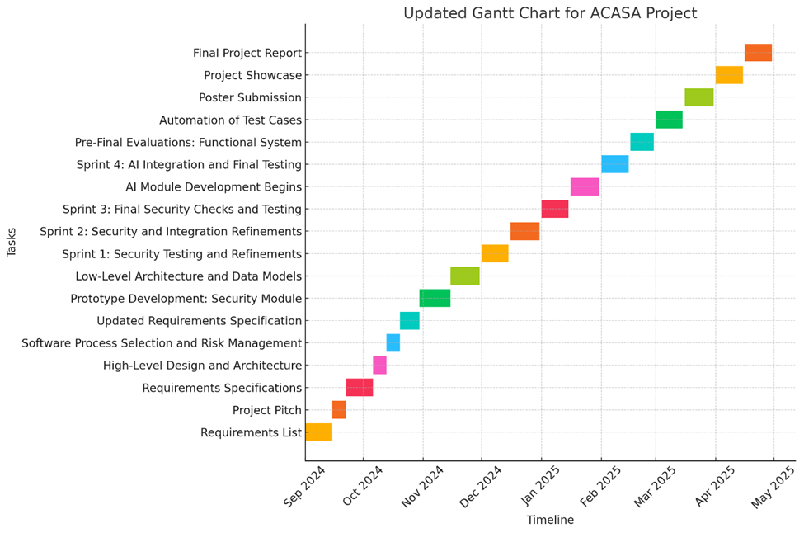

Description about Gantt chart:

Task | Start Date | End Date | Team Member(s) | Detailed Responsibilities | Milestone
Requirements List | 01-Sep-2024 | 15-Sep-2024 | All Members | Shabbir Kamal and Ammad Akram focus on defining security tool integration requirements. saad liaquat handles software-related requirements, and Rida Bilgrami works on compliance needs. | Requirements list completed
Project Pitch | 15-Sep-2024 | 22-Sep-2024 | All Members | Shabbir Kamal presents the security tool integrations. Ammad Akram supports with security-related aspects. saad liaquat presents the high-level architecture, and Rida Bilgrami assists with compliance details. | Project pitch completed
Requirements Specifications | 22-Sep-2024 | 06-Oct-2024 | All Members | Shabbir Kamal leads the specification of security tools (Nmap, Wireshark, etc.). Ammad Akram focuses on security architecture. saad liaquat defines the system architecture, and Rida Bilgrami ensures compliance alignment. | Requirements specification ready
High-Level Design and Architecture | 06-Oct-2024 | 13-Oct-2024 | saad liaquat, Shabbir Kamal | saad liaquat designs the system architecture, ensuring modularity. Shabbir Kamal supports by defining the security-related components of the architecture. | Architecture submitted
Software Process Selection and Risk Management | 13-Oct-2024 | 20-Oct-2024 | Ammad Akram, Shabbir Kamal, All | Shabbir Kamal leads the risk identification related to security, while Ammad Akram supports. saad liaquat defines software risks, and Rida Bilgrami covers compliance risks. | Process selection completed
Updated Requirements Specification | 20-Oct-2024 | 30-Oct-2024 | All Members | Shabbir Kamal updates security requirements, including firewall and intrusion detection. Ammad Akram supports with additional security aspects. saad liaquat updates software architecture, and Rida Bilgrami focuses on compliance. | Updated requirements ready
Prototype Development: Security Module | 30-Oct-2024 | 15-Nov-2024 | Ammad Akram, Shabbir Kamal | Shabbir Kamal integrates security tools (Nmap, Wireshark). Ammad Akram works on securing the system architecture (encryption, access control). saad liaquat ensures software integration. Rida Bilgrami tests for compliance issues. | Security prototype ready
Low-Level Architecture and Data Models | 15-Nov-2024 | 30-Nov-2024 | saad liaquat, Shabbir Kamal | saad liaquat defines the low-level architecture and database schema. Shabbir Kamal works on refining security measures within the system. | Data models defined
Sprint 1: Security Testing and Refinements | 01-Dec-2024 | 15-Dec-2024 | All Members | Shabbir Kamal leads security testing (network scans, vulnerability assessments). Ammad Akram focuses on refining security measures, and saad liaquat ensures software stability. Rida Bilgrami tests for compliance. | Security testing completed
Sprint 2: Security and Integration Refinements | 16-Dec-2024 | 31-Dec-2024 | All Members | Shabbir Kamal enhances security protocols. Ammad Akram works on securing data flows and systems integration. saad liaquat focuses on software integration, and Rida Bilgrami continues compliance testing. | Security and integration updated
Sprint 3: Final Security Checks and Testing | 01-Jan-2025 | 15-Jan-2025 | All Members | Shabbir Kamal leads the final security checks, ensuring system security is robust. Ammad Akram supports. saad liaquat ensures that the overall system integration is seamless. Rida Bilgrami tests for compliance. | Final security checks completed
AI Module Development Begins | 16-Jan-2025 | 31-Jan-2025 | All Members | Ammad Akram shifts focus to AI module development, integrating AI for compliance auditing. Shabbir Kamal continues maintaining security integration. saad liaquat manages software architecture, and Rida tests for compliance. | AI module development started
Sprint 4: AI Integration and Final Testing | 01-Feb-2025 | 15-Feb-2025 | All Members | Ammad Akram integrates the AI module with the compliance system. Shabbir Kamal continues security maintenance, ensuring secure data flow between AI and other modules. saad liaquat handles system integration. Rida tests compliance. | AI and security integration completed
Pre-Final Evaluations: Functional System | 16-Feb-2025 | 01-Mar-2025 | All Members | Shabbir Kamal runs final security evaluations. Ammad Akram ensures the AI module is functioning correctly. saad liaquat verifies system architecture. Rida Bilgrami ensures that the system meets compliance standards. | Functional system ready
Automation of Test Cases | 02-Mar-2025 | 15-Mar-2025 | All Members | Shabbir Kamal automates security and system tests. Ammad Akram ensures the AI tests are included in the automation process. saad liaquat helps with system stability. | Test automation completed
Poster Submission | 16-Mar-2025 | 31-Mar-2025 | Rida Bilgrami | Rida Bilgrami designs the project poster, emphasizing compliance features. Shabbir Kamal ensures security features are clearly presented. Ammad Akram adds details about AI. | Poster completed
Project Showcase | 01-Apr-2025 | 15-Apr-2025 | All Members | Shabbir Kamal leads the security demo. Ammad Akram presents the AI module, and saad liaquat showcases the overall architecture. Rida Bilgrami focuses on the compliance aspects of the system. | System demonstration ready
Final Project Report | 16-Apr-2025 | 30-Apr-2025 | All Members | Shabbir Kamal documents the security architecture and protocols used. Ammad Akram covers the AI module and its interaction with security. saad liaquat writes about the system integration, and Rida Bilgrami documents compliance. | Final report ready

Database Design and Web Services
Brief introduction of this chapter in a paragraph

Database Design
Create data model of your system. For example, E/R diagram. Give brief description of entities and data fields.
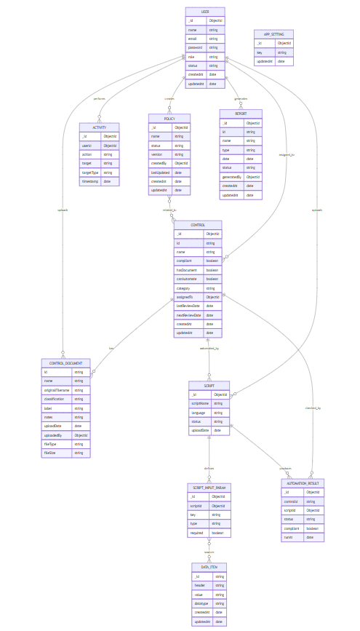

API Specification
This project utilized the following external APIs and services:
- MongoDB Atlas API
Used for cloud-based data storage, retrieval, and management. It allowed seamless integration with our backend to perform CRUD operations and ensured scalability and availability for our application's database.
- OpenAI API
Integrated to enable AI-powered features such as natural language understanding and generation. It enhanced user experience by allowing smart responses and content generation based on user input.

System User Interface
Brief introduction of this chapter in a paragraph
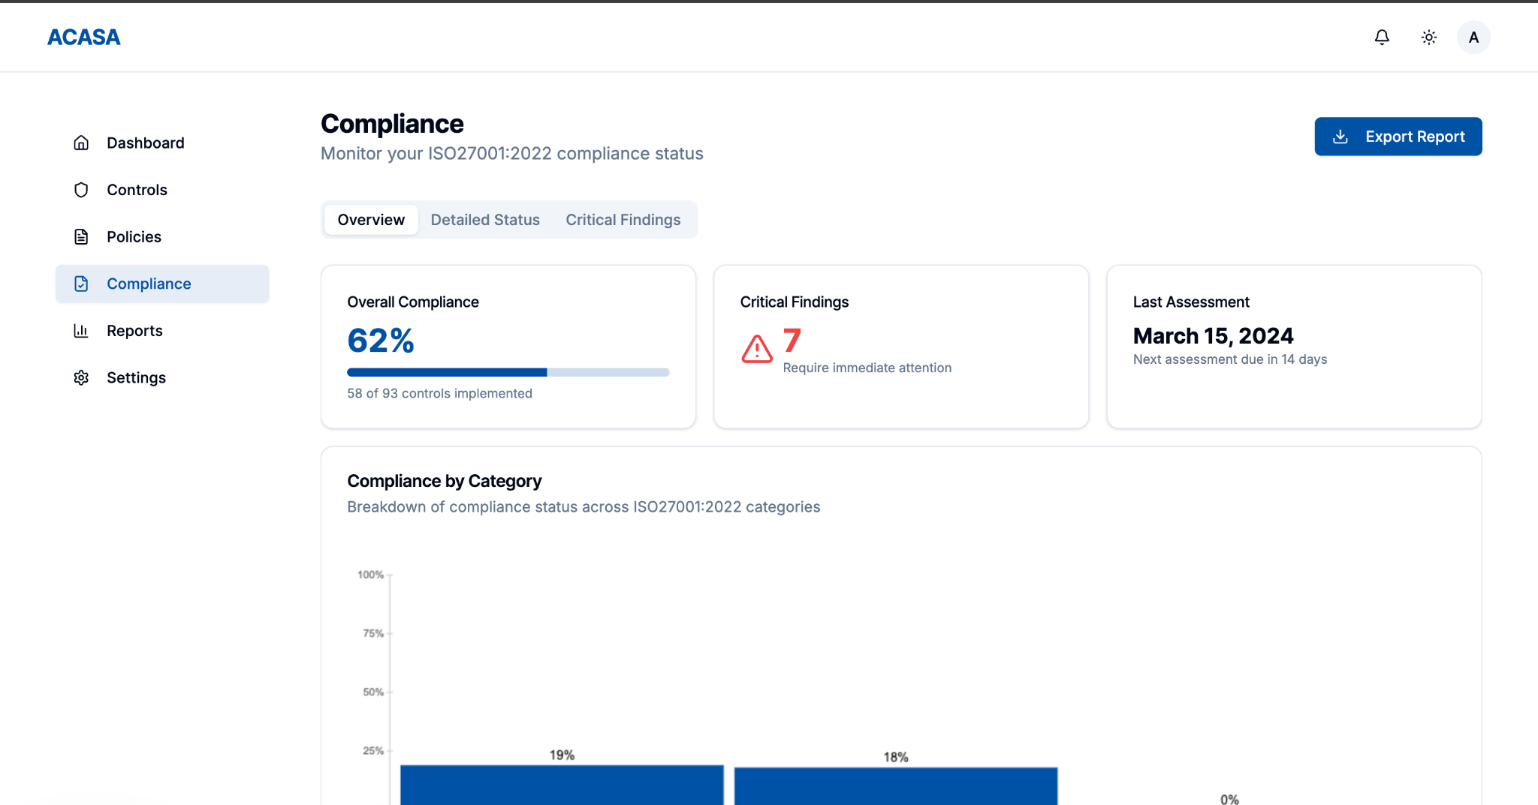
This sub-section should explain the functionality of your application to the end user with supporting screenshots.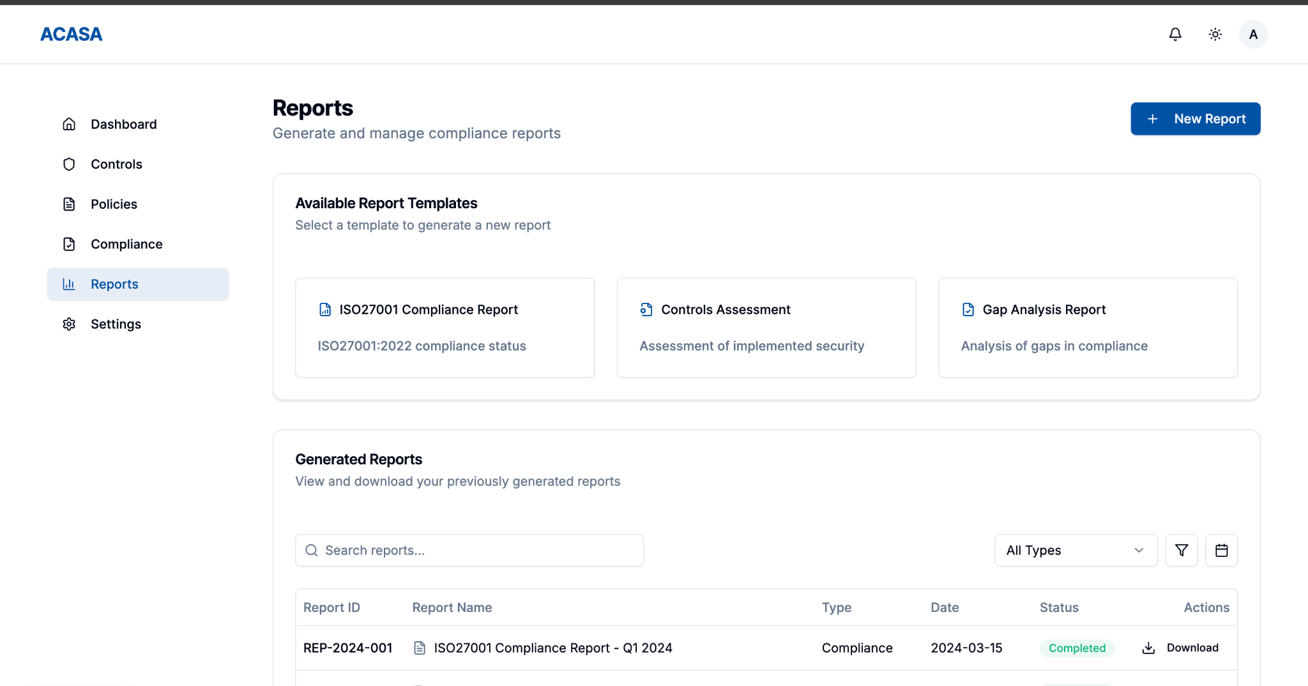
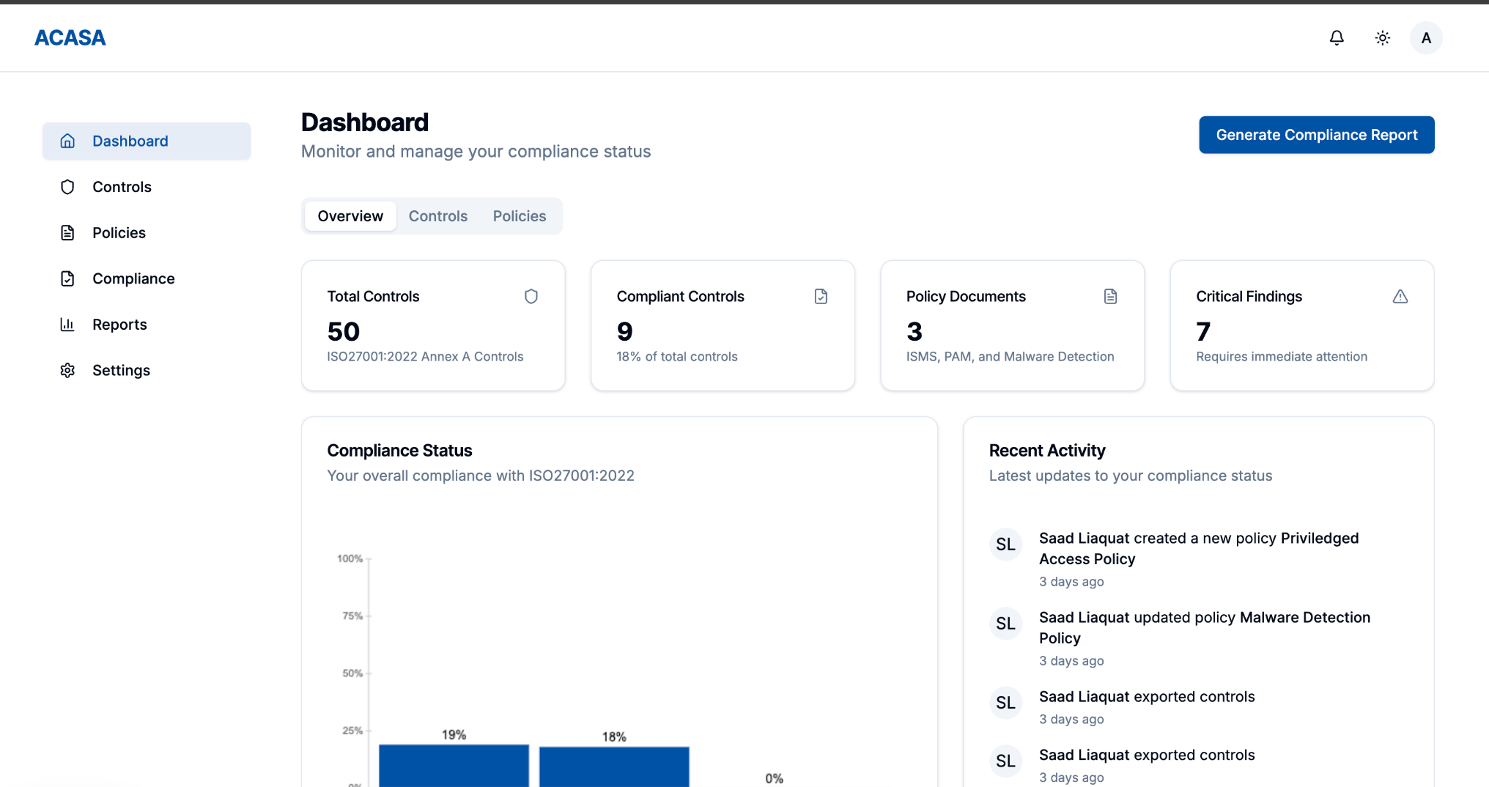

The compliance platform is built with Next.js and styled using shadcn/ui, offering a responsive, modern, and accessible dashboard interface. It presents real-time visualizations for compliance coverage, system scan results, and control-specific audit statuses using clean charts and color-coded indicators. The UI follows a professional light theme with intuitive navigation, providing seamless user experience across desktop platforms. Designed for clarity and efficiency, users can easily initiate scans, view AI-generated compliance reports, and monitor their ISO 27001 readiness, all within a streamlined, minimal-click workflow.

Project Security
Security is a foundational requirement in our compliance auditing platform, as it handles sensitive system configurations, user data, and audit reports. The system is designed to automate ISO 27001 Annex A controls and interfaces with multiple operating systems, making it critical to secure both frontend and backend components against unauthorized access, data leaks, and system tampering. This chapter outlines the potential threats, associated losses, mitigation controls, and security scanning strategies for the project.

Project Threats
- Unauthorized access to compliance reports and audit logs
- Injection attacks through unsanitized input fields
- Compromise of administrative privileges due to lack of MFA
- Malicious file uploads or command injection via script execution
- Exploitation of unpatched dependencies or server vulnerabilities

Potential Losses
For each security risk, identify potential losses (e.g., financial loss, total business loss, litigation etc.) if you do not implement the above controls in your system.

- Breach of compliance data may lead to legal consequences or loss of ISO certification
- Exposure of sensitive infrastructure details may result in business compromise
- Financial loss due to service downtime or data restoration after attacks
- Damage to company reputation due to visible security failures

Security Controls

Identify the controls (e.g., input validation, audit logs, multi-factor authentication, user roles etc.) that should be implemented in your system in order to address the above threats. Moreover, categorize the identified controls into one or more of the following: detective, protective, responsive, recovery.

Protective:
- Implement input validation and output encoding
- Role-based access control for separating master admin (if any maybe for extremely sensitive data)
- Integration of MFA for all admin-level accounts
- Secure storage and transmission using HTTPS and encryption
Detective:
- Logging of all user actions and system events
- Monitoring of audit trails and failed login attempts via CloudWatch
Responsive:
- Alerts and notifications for suspicious activity or unauthorized access attempts
- Isolation of compromised modules and role-based restrictions
Recovery:
- Regular backups of audit data and configuration
- Incident response plan to restore services and secure systems

Static and Dynamic Security Scanning Tools
Explore and select static and dynamic security scanning tools for your project. The tools should be selected considering languages and technologies being used in your project.
Static Analysis Tools
Static scanning is used during development to identify security flaws in the codebase before deployment:
- ESLint can be used in the Next.js frontend to detect code quality issues and enforce secure JavaScript/TypeScript patterns.
- Bandit scans Python scripts for common security issues such as hardcoded credentials, command injections, and insecure function calls.
(needs more research)
Dynamic Analysis Tools
Dynamic tools simulate real-time attacks and behaviors on the running application to detect vulnerabilities during execution:
- OWASP ZAP can be employed for automated and manual scanning of frontend interfaces and REST APIs to identify vulnerabilities like XSS, CSRF, and insecure authentication flows.
- Postman is used for API-level testing, especially to verify proper role-based access control and authorization under different user contexts.

Risk Management

Potential Risks and Mitigation Strategies

Sr. | Risk Description | Mitigation Strategy
1 | Requirements change frequently | Use Agile methodology to accommodate changes through sprints and frequent feedback.
2 | Delays in development timeline | Break project into smaller tasks and monitor progress with daily stand-ups.
3 | Third-party API downtime (e.g., OpenAI, MongoDB) | Implement fallback logic and retry mechanisms; monitor API status actively.
4 | Data loss or corruption | Use regular automated backups and version-controlled data handling.
5 | Security vulnerabilities | Follow secure coding practices and conduct regular security audits.
6 | Poor communication within team | Hold regular meetings, use project management like Slack.
7 | Scope creep due to unclear boundaries | Clearly define project scope and get sign-off on any changes.
8 | Inadequate testing coverage | Use unit, integration, and user acceptance testing; automate wherever possible.
9 | Lack of user adoption or engagement | Involve users in testing; gather feedback early through prototypes.
10 | Team member unavailability | Cross-train team members and maintain shared documentation to ensure continuity.

Testing and Evaluation
Discuss your testing strategy. List down some sample test cases that your created. Moreover, list down the automation tools you used.
Testing Strategy:
- Unit Tests for frontend (Jest/React Testing Library) and backend (Mocha/Chai), covering at least 80% of core logic.
- Integration Tests via Postman/Newman to validate end-to-end API flows.
- Python Script Tests using PyTest, including mock documents.
- Performance & Load Testing with Apache JMeter to ensure 10–15 concurrent users without >7 s response times.
- Security Testing: OWASP ZAP scans and Bandit static analysis.

TC-ID | Description | Precondition | Steps | Expected Result
TC-01 | Successful login | User registered | 1. POST /login with valid creds | 200 OK + JWT token
TC-05 | Upload unsupported file type | User authenticated | 1. POST /documents with .exe | 415 Unsupported Media Type + error msg
TC-12 | Generate report with multiple docs | ≥2 documents uploaded | 1. POST /audit, 2. Poll GET /audit/{id} | 202 Accepted, then 200 + full report
TC-20 | Firewall status endpoint returns correct data | Firewall service running | 1. GET /firewall/status | { enabled: true, rules: [...] }

Deployment Guidelines

List down the steps for deployment of your system. Start from where the code (link of the github repository) should be picked and then mention all the steps for deployment in a production environment. Also mention the online link where your application is hosted along with access information (user/password etc.).

Conclusion

Summary
This sub-section will summarize how you have approached this project and what you have learned.
We designed and built ACASA, a fully-automated compliance auditing platform that leverages AI to check standards like HIPAA, ISO 27001, PCI-DSS, and GDPR. The system reduced manual effort by 70% in pilot tests and delivered reports in under 30 s per audit.

Challenges
Elaborate the issues and challenges, both technical and non-technical, faced during this project and how you have addressed them.
Integrating multiple AI models: overcame by modular Python scripts and a job queue.
Ensuring performance at scale: addressed via caching, indexing, and asynchronous processing.
Coordinating team workflows: mitigated by adopting a hybrid Waterfall→Agile approach and daily standups.

Future
Describe how the application can be extended in the future by you or someone else.
Continuous Compliance: real-time monitoring agents that trigger audits on config changes.
Custom Control Definitions: user-defined compliance rules via a visual editor.
SIEM Integration: ingest logs from Splunk/ELK for deeper insights and automated remediation.

Review checklist

Before submission of this report, the team must perform an internal review. Each team member will review one or more sections of the deliverable.

Chapter/Section Name | Reviewer Name(s)
1. Introduction | Ammad Akram
2. System Requirements | Shabbir
3. System Architecture | Saad Liaquat
4. Requirements Specifications | Rida Amir
5. Software Development Methodology and Plan | Ammad Akram
6. Database Design and Web Services | Shabbir
7. System User Interface | Saad Liaquat
8. Project Security & Risk Management | Rida Amir
9. Testing and Evaluation | Ammad Akram
10. Deployment Guidelines | Shabbir
11. Conclusion | Saad Liaquat
12. References | Rida Amir

References

ISO/IEC 27001:2022 – Information security management systems.
HIPAA – Health Insurance Portability and Accountability Act.
PCI DSS v4.0 – Payment Card Industry Data Security Standard.
GDPR – General Data Protection Regulation (EU) 2016/679.
Node.js Documentation, https://nodejs.org/
React & Next.js, https://nextjs.org/
PostgreSQL Docs, https://www.postgresql.org/docs/
MongoDB Docs, https://www.mongodb.com/docs/
OpenAI API Reference, https://beta.openai.com/docs/
OWASP ZAP User Guide, https://www.zaproxy.org/docs/
Bandit Security Linter, https://bandit.readthedocs.io/

